|  |
| --- |
|  |
| THE CAKE SHOP |
| Project Documentation of DISM (Semester II) |

SAHAR MUSHTAQ KHANJI

**Faculty** = Miss Aatika Liaquat

**Batch Code** = 1803B2

**Curriculum**= 6673

**Semester**= HDSE-2

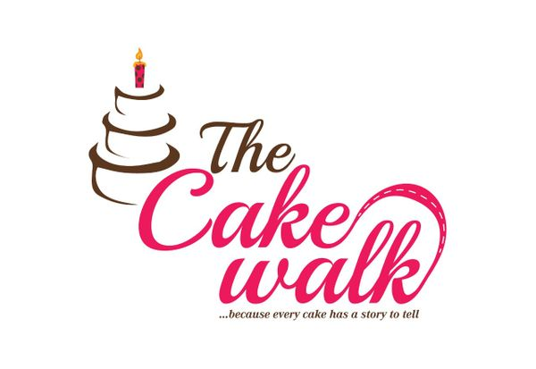

Login Page: -

This is the entry point of our application. First of all you’ll see this page then you can select your role from combo box and if your id password matches with the id password in our data base you can see the nest page. 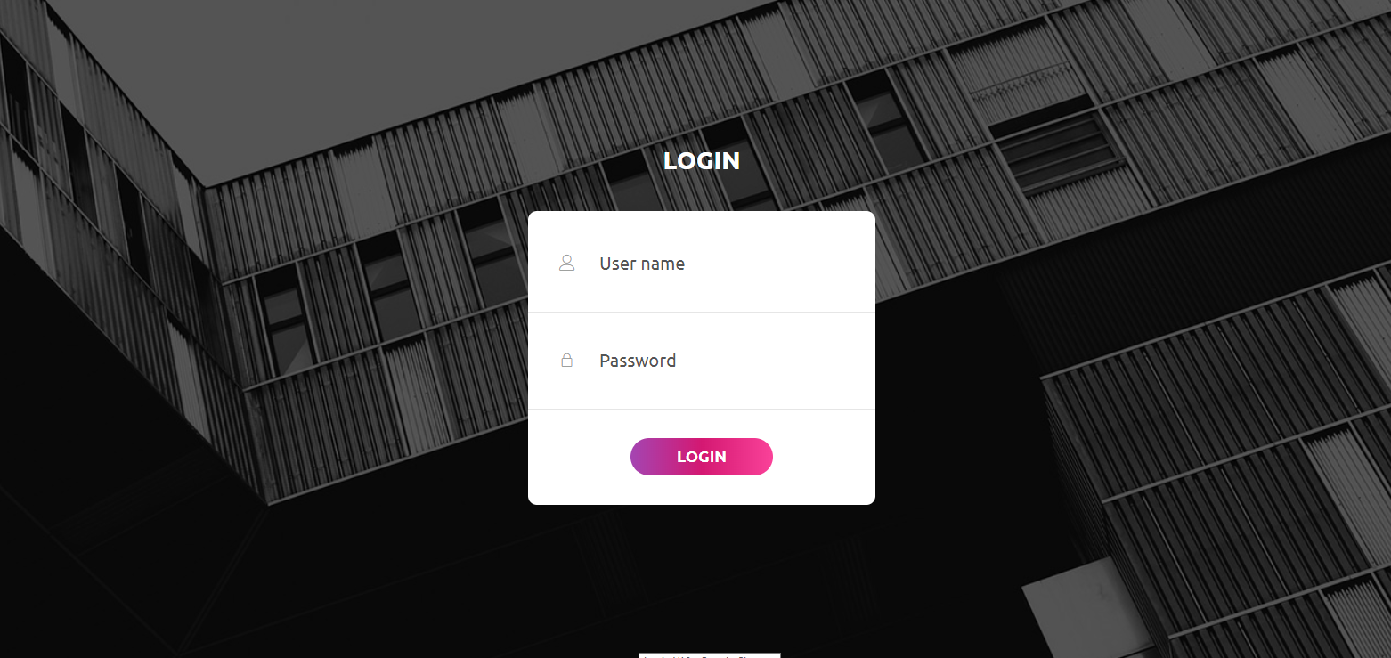



HOME:-

THIS IS OUR HOME PAGE AND ITS OUR HEADER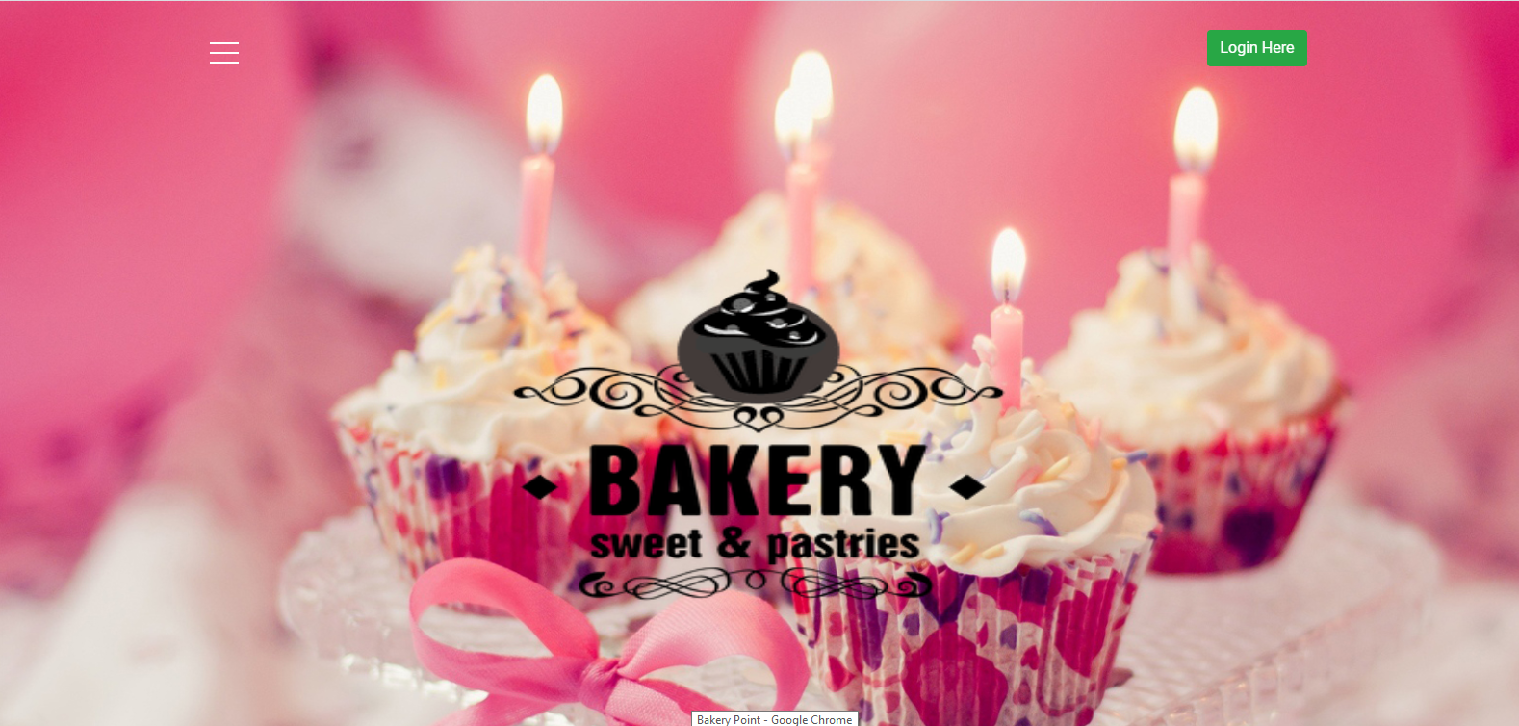

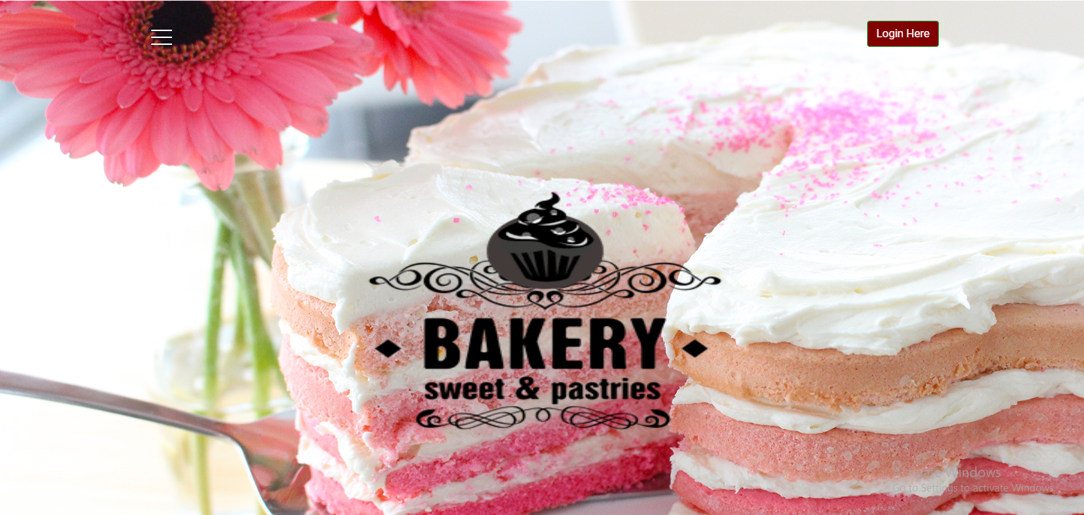

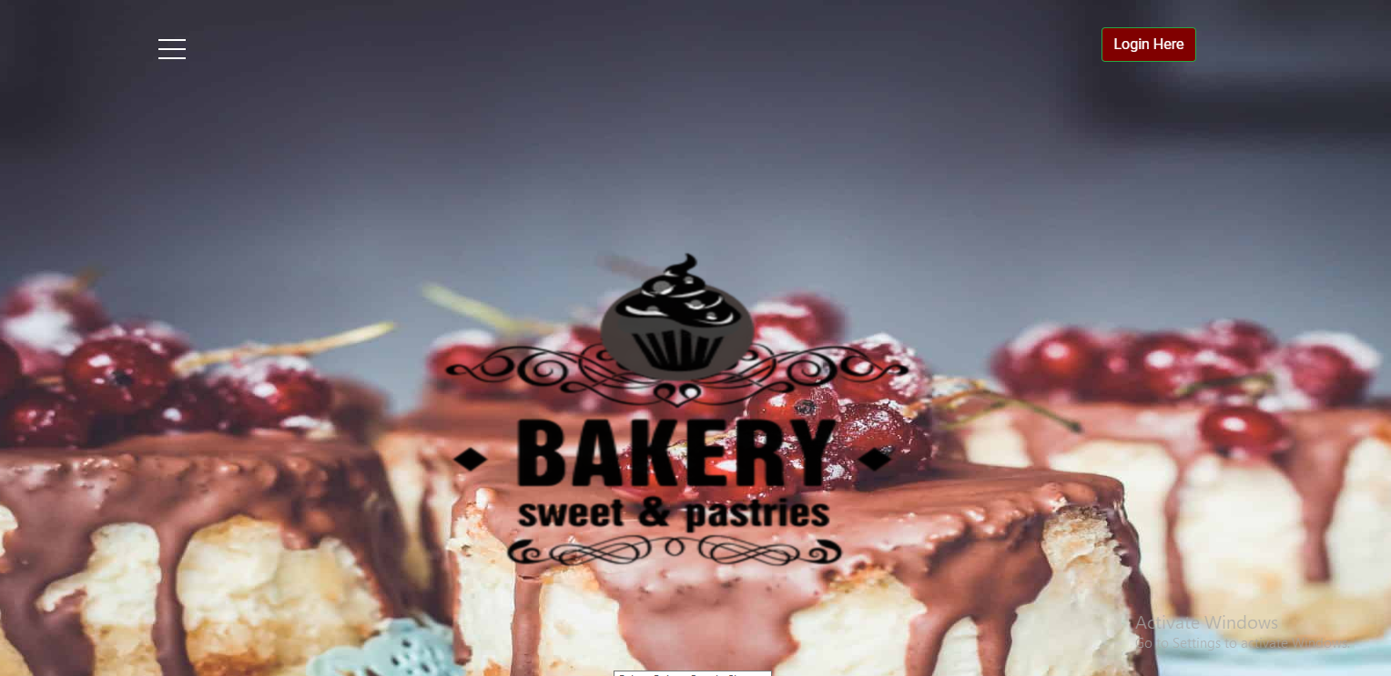



ABOUT: -

THIS IS OUR ABOUT PAGE

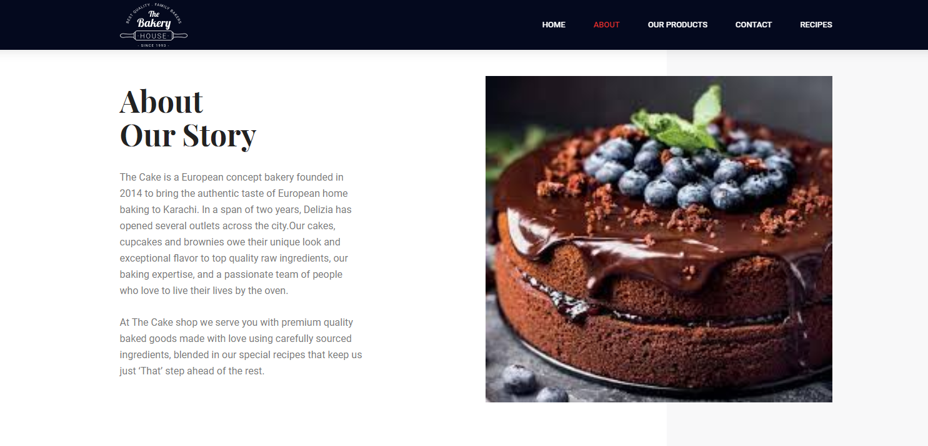

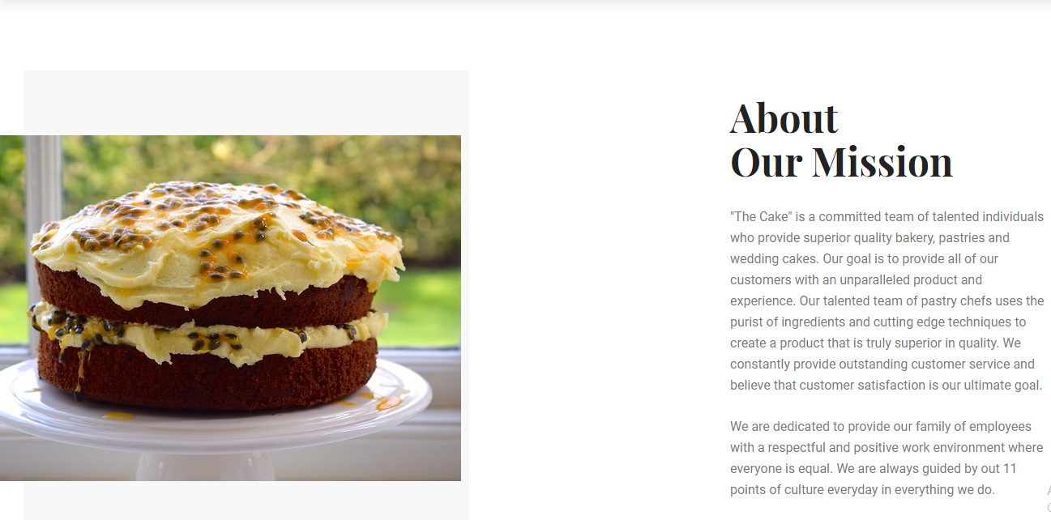



## 

EVENTS: -

HERE IS OUR PRODUCT SORT BY EVENTS

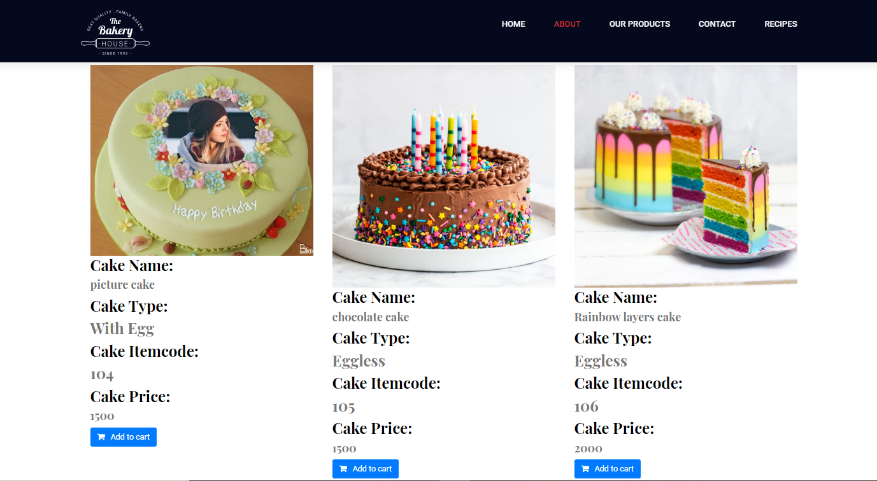



CONTACT: -

THIS IS OUR CONTACT PAGE

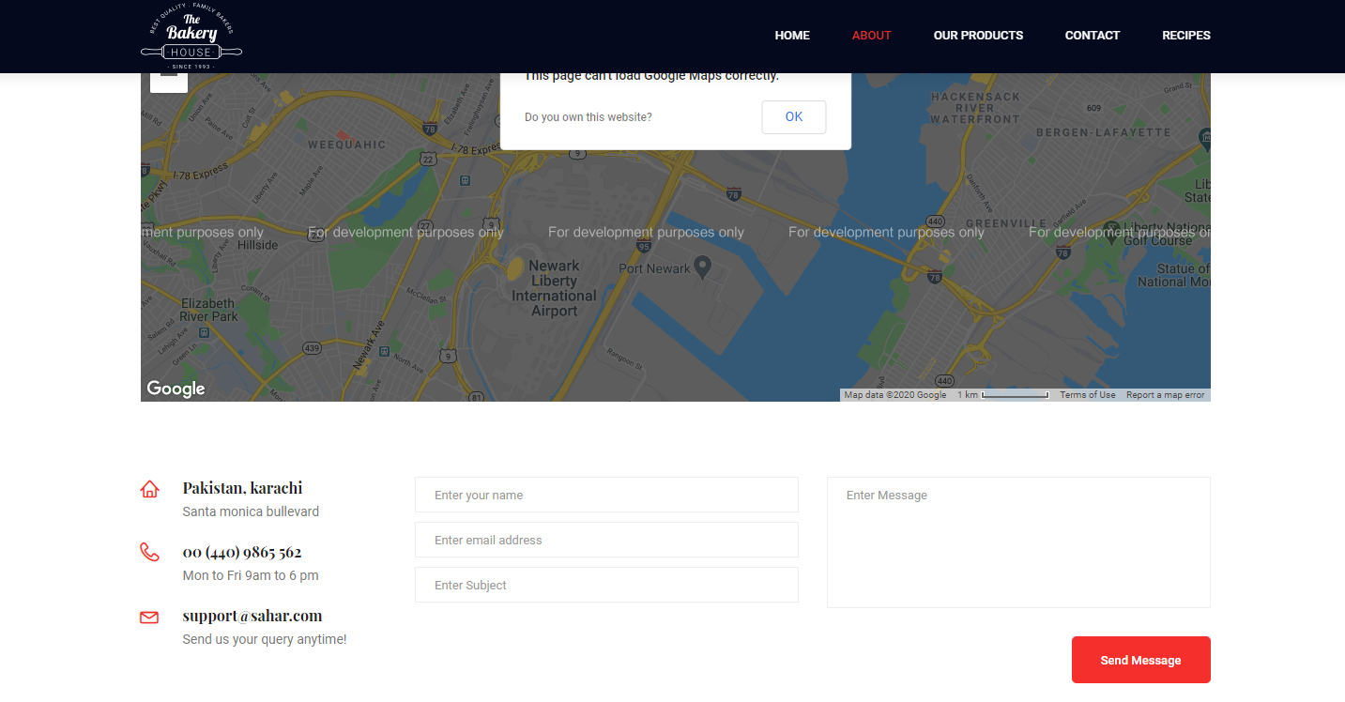



RECIPE OF THE DAY: -

This is our recipe card

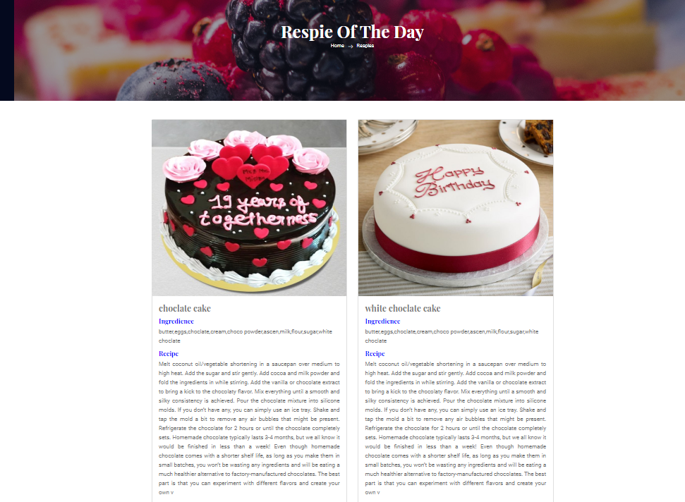



DASHBOARD: -

This is our dashboard admin

